Machine Learning

**Week 1**

**Lecture 1**

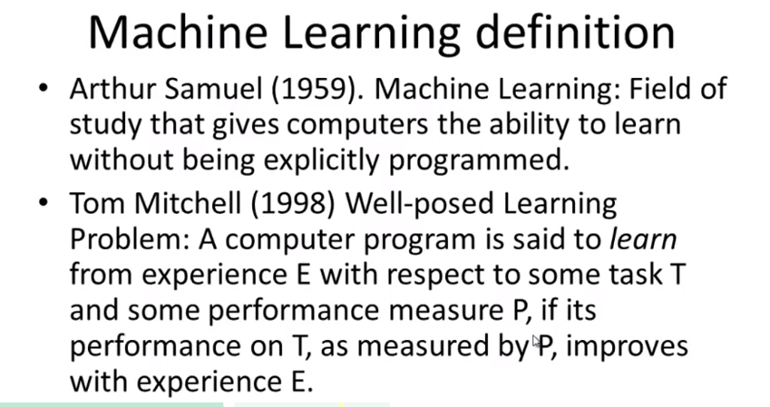

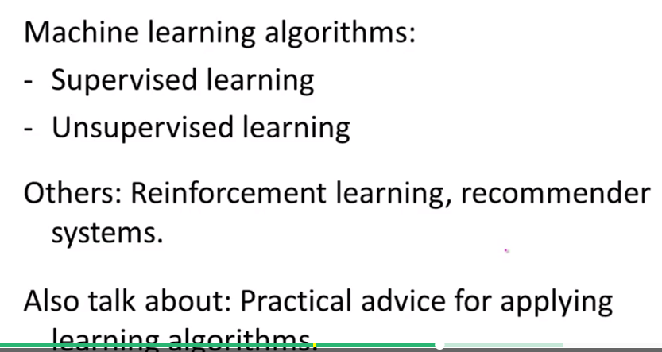

Supervised learning: Teach computer to learn

Unsupervised learning: Let computer learn by itself

**Lecture 1-2 – Supervised Learning:**

**“Right answers” given**

Regression: Predict continuous valued output (price in the example)

Classification problem: Discrete valued output (0 or 1)

**Lecture 1-3 – Unsupervised Learning:**

Cocktail party algorithm



svd: single value decomposition

**Lecture 2**

**Lecture 2-1 Model Representation**

1. Training set

m: number of training examples

(x,y): one training example

(x(i),y(i)): i-th training example

h: hypothesis

**Lecture 2-2 Cost function J**

Squared error cost function

**Lecture 2-3 Cost function intuition I**

**Lecture 2-4 Cost function intuition II**

Contour figures

**Lecture 2-5 Gradient Descent**

:= this is assignment symbol

= this is truth assertion

$α$: Learning rate

Correct: Simultaneous update

**Lecture 2-5 Gradient Descent Intuition**

$α$: Learning rate

* If too small, gradient descent can be slow
* If too large, gradient descent can overshoot the minimum. May fail to converge, or even diverge.

**Lecture 2-5 Gradient Descent for linear regression**

1. Convex function: Bowl-shape, no local minimum, only one global minimum

2. “Batch” gradient descent

**Lecture 3**

**Lecture 3-1 Matrices and Vectors**

**This course assumes 1-indexed vector**

Octave/Matlab Command

% The ; denotes we are going back to a new row.

A = [1, 2, 3; 4, 5, 6; 7, 8, 9; 10, 11, 12]

% Initialize a vector

v = [1;2;3]

% Get the dimension of the matrix A where m = rows and n = columns

[m,n] = size(A)

% You could also store it this way

dim_A = size(A)

% Get the dimension of the vector v

dim_v = size(v)

% Now let's index into the 2nd row 3rd column of matrix A

A_23 = A(2,3)

**Lecture 3-2 Addition and Scalar multiplication**

Octave/Matlab command

% Initialize matrix A and B

A = [1, 2, 4; 5, 3, 2]

B = [1, 3, 4; 1, 1, 1]

% Initialize constant s

s = 2

% See how element-wise addition works

add_AB = A + B

% See how element-wise subtraction works

sub_AB = A - B

% See how scalar multiplication works

mult_As = A * s

% Divide A by s

div_As = A / s

% What happens if we have a Matrix + scalar?

add_As = A + s

**Lecture 3-3 Matrix * Vector**

% Initialize matrix A

A = [1, 2, 3; 4, 5, 6;7, 8, 9]

% Initialize vector v

v = [1; 1; 1]

% Multiply A * v

Av = A * v

**Lecture 3-4 Matrix * Matrix**

% Initialize a 3 by 2 matrix

A = [1, 2; 3, 4;5, 6]

% Initialize a 2 by 1 matrix

B = [1; 2]

% We expect a resulting matrix of (3 by 2)*(2 by 1) = (3 by 1)

mult_AB = A*B

% Make sure you understand why we got that result

**Lecture 3-6 Inverse and Transpose**

% Initialize matrix A

A = [1,2,0;0,5,6;7,0,9]

% Transpose A

A_trans = A'

% Take the inverse of A

A_inv = inv(A)

% What is A^(-1)*A?

A_invA = inv(A)*A

**Week 2**

**Lecture 1 – Multi regression**

1. For convenience, x0=1

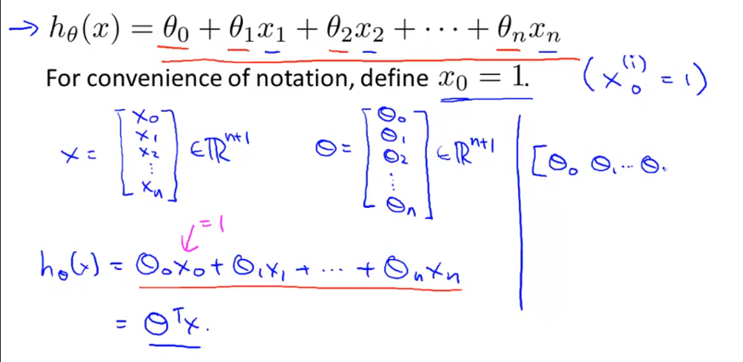

**Lecture 2 – Feature Scaling**

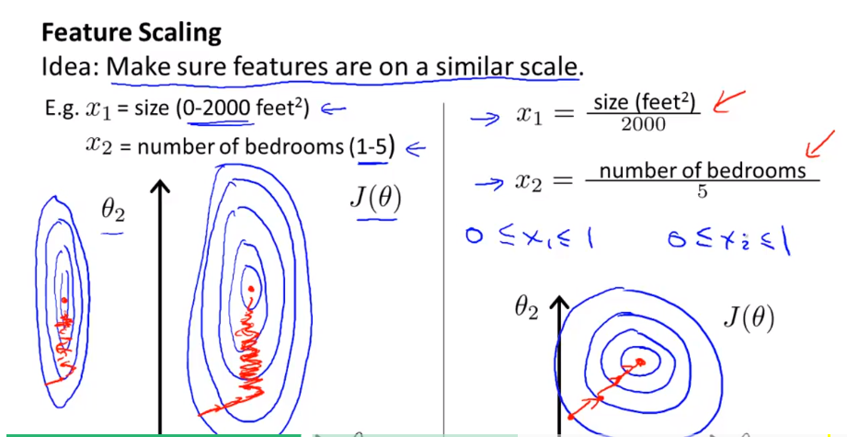

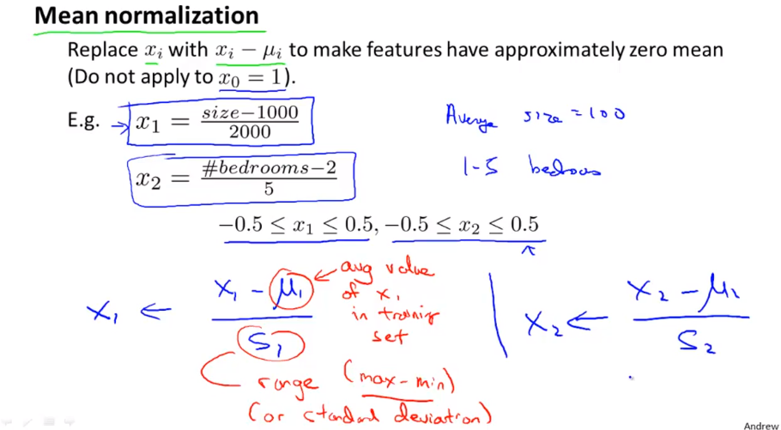

**Learning Rate $α$**

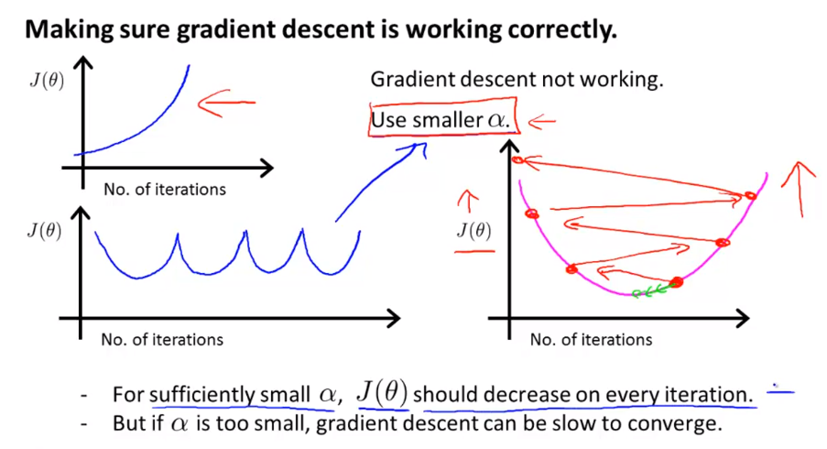

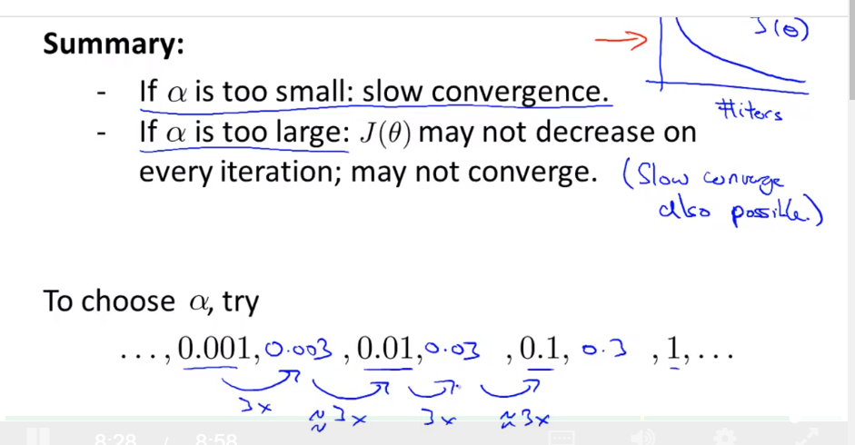

**Polynomial Regression**

**Normal Equation**

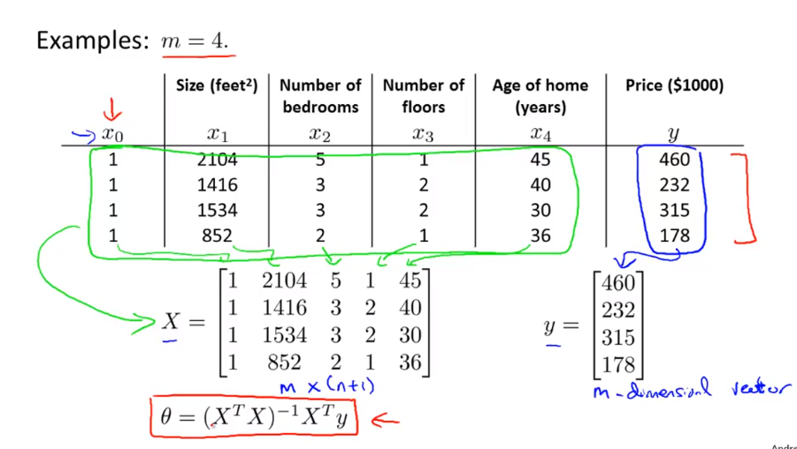

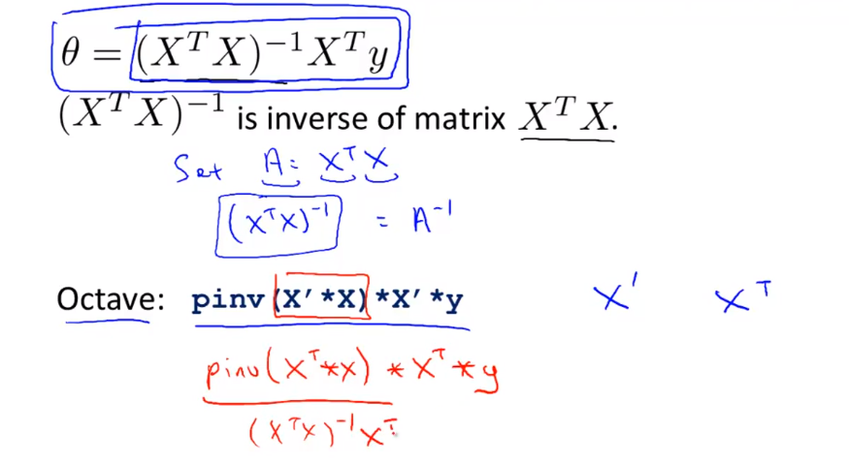

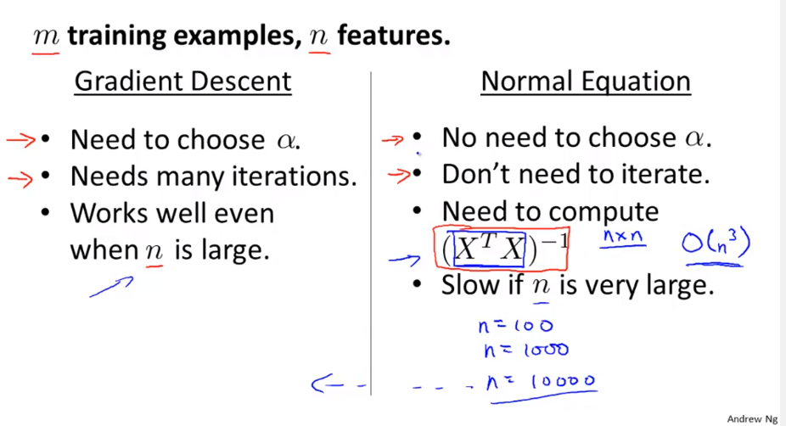

If Normal Equation is non-invertiable, pinv in Octave can also compute this

**Octave Tutorial – Basic operations**

Octave is open-source

ML: Octave, Matlab, Python, Numpy, R

% comment

~= not equal

&& AND

|| OR

2^6 power

xor(1,0)

PS1(‘>> ‘); change the octave symbol to >> symbol

; semicolon suppressing output, not output the result

disp(sprint(‘2 decimals: %0.2f’, a))

format long

format short

V=1:0.1:2 will generate a row vector from 1 to 2 with increment 0.1

ones(2,3) 2 by 3 matrix with all 1s

2* ones(2,3)

zeros(1,3)

rand(1,3) random number with [0,1]

randn(1,3) Normal random variable

hist(w)

hist(w,50) 50 bins

eye(4) 4 by 4 identity matrix

help eye

**Octave – Moving data Around**

size(A) a by b dimension matrix

size (A,1) row

size(A,2) column

length(A) longest dimension, usually used for vector

load featuresX.dat

load(‘featuresX.dat’)

who variables in current scope

whos detailed information of variables in current scope

clear a remove variable a

save hello.mat v; save v to a file called hello.mat

clear will delete all variables

save hello.txt v –ascii %save as text (ASCII)

A(3,2)

A(2,:)

A(:,2)

A([1 3],:)

A(:,2) = [10;11;12]

A = [A, [100;101;102]] Append a column vector to the right of A

A(:) put all elements of A into a single vector

C=[A B] or C =[A,B] put B to the right of A

C= [A; B] put B to the bottom of A

**Computing on Data**

A .* B element wised computation, A11*B11 A12*B12

A .^2 element wised square

1 ./v element wised of v

log(v)

exp(v)

v+ones(length(v),1) v+1

A’ transpose of A

[val, ind]=max(a) return the value and index of that value

max(A) column wised maximum

find(a<3) return the index

magic(3) all sums of rows or columns , diagonal is same

[r,c]=find(A>=7) row, column

Prod(a) product of all elements of a

floor(a) ceil(a)

max(A,[],1) 1 1st dimension of A

max(A,[],2) maximum of each row

sum(A,1) add all elements of each column, column wised sum

sum(A,2) add all elements of each row

A .*eye(9) get the diagonal

A .*flipud(eye(9)) the other diagonal

pinv(A) sudo-inverse

**Plotting Data**

plot

plot(t,y1); holds on; plot(t,y2,’r’);

xlabel(‘time)

ylabel(‘value)

legend(‘sin’,’cos’)

title(‘my plot’)

cd ‘C:\Users\sc492qk\Desktop’; print –dpng ‘myplot.png’ save the file as png

close; close figure

figure(1); plot(t,y1);

figure(2); plot(t,y2);

subplot(1,2,1); % Divides plot a 1x2 grid, access first element

plot(t,y1);

subplot(1,2,2); plot (t,y2);

axis([0.5 1 -1 1] x-axis y-axis

clf; clear figure

imagesc(A)

imagesc(A),colorbar, colormap gray; plot the matrix to a color map

**Control statements – for, while, if**

for i=1:10,

v(i)=2^i;

end;

i=1;

while 1<=5,

v(i)=100;

i=i+1;

end;

i=1;

while true,

v(i)=999;

i=i+1;

if i==6;

break;

end;

end;

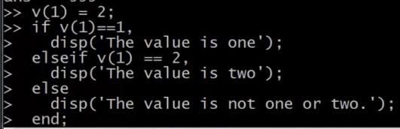

Function .m file

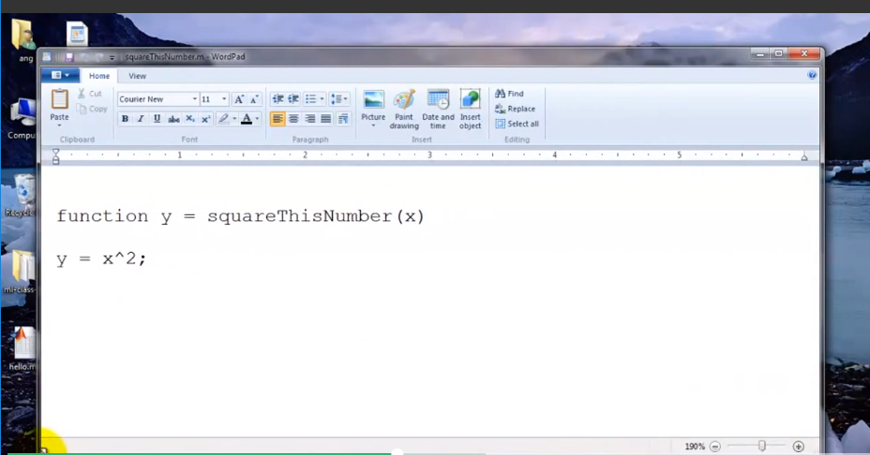

pwd

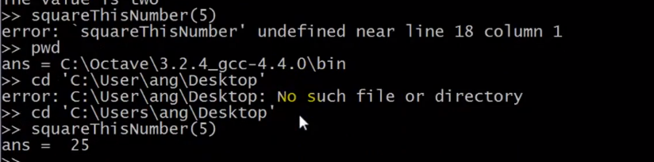

addpath(‘….’)

can still use the function file stored in this file location (path)

**Cost function**

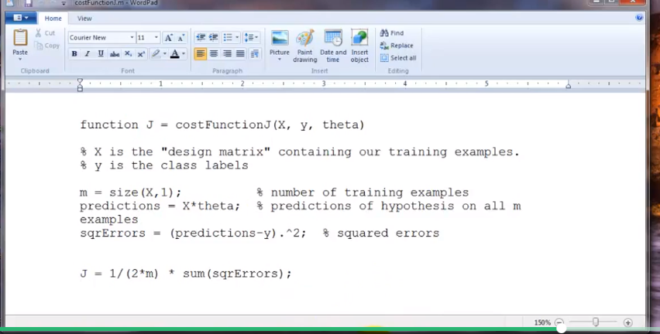

**Vectorization**

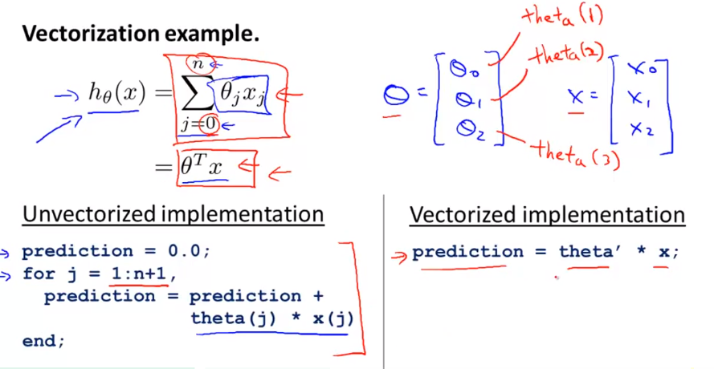

**Week 3 – Logistic Regression**

**Classification**

0: negative class

1: positive class

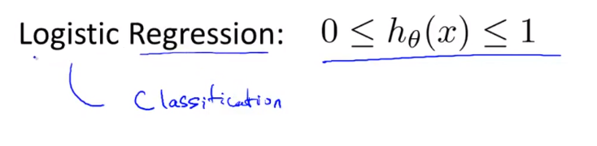

**Hypothesis representation**

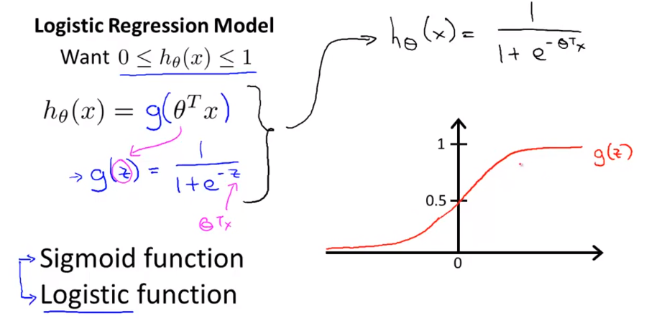

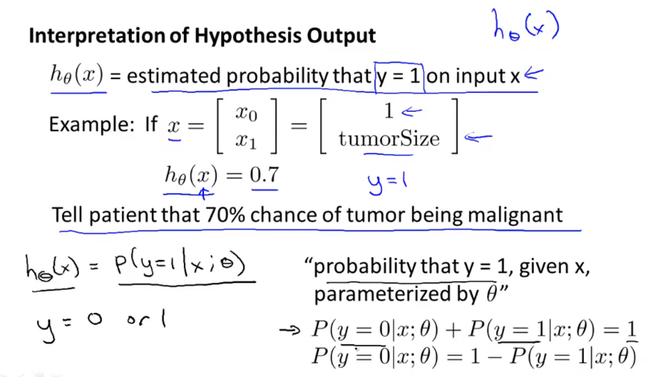

**Decision Boundary**

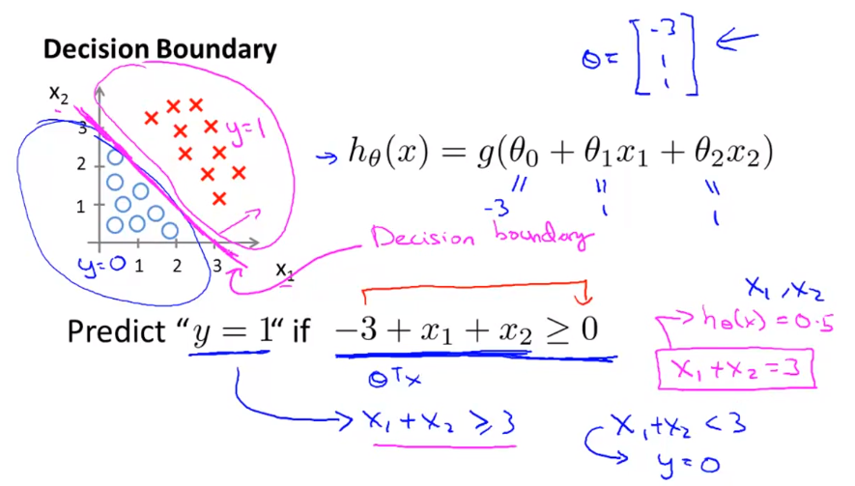

**Cost function**

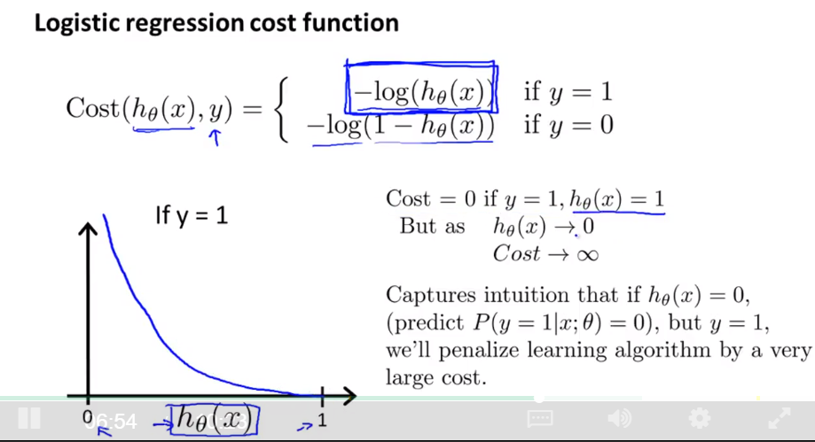

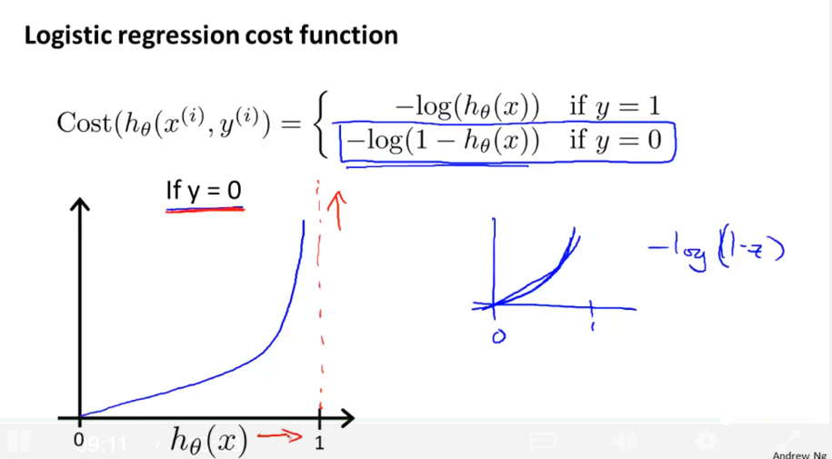

**Simplified Cost Function and Gradient Descent**

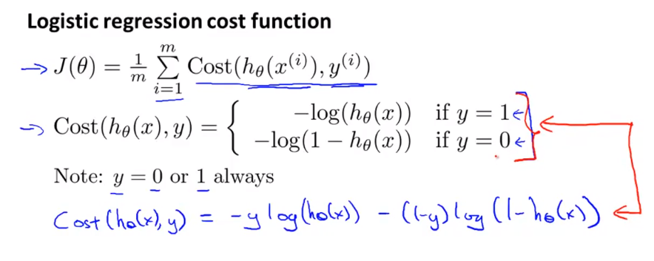  
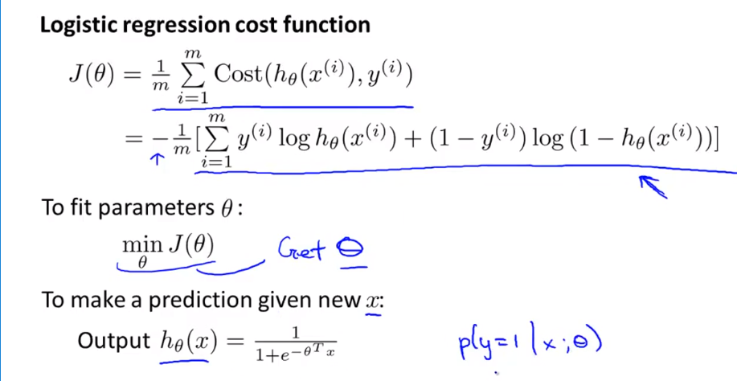

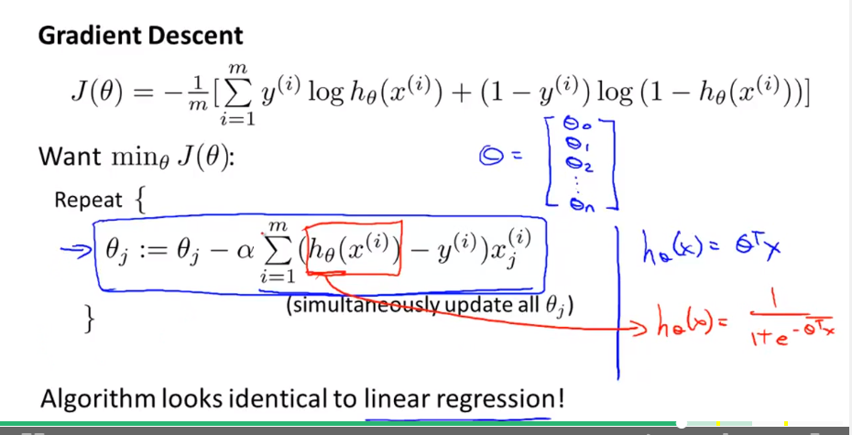

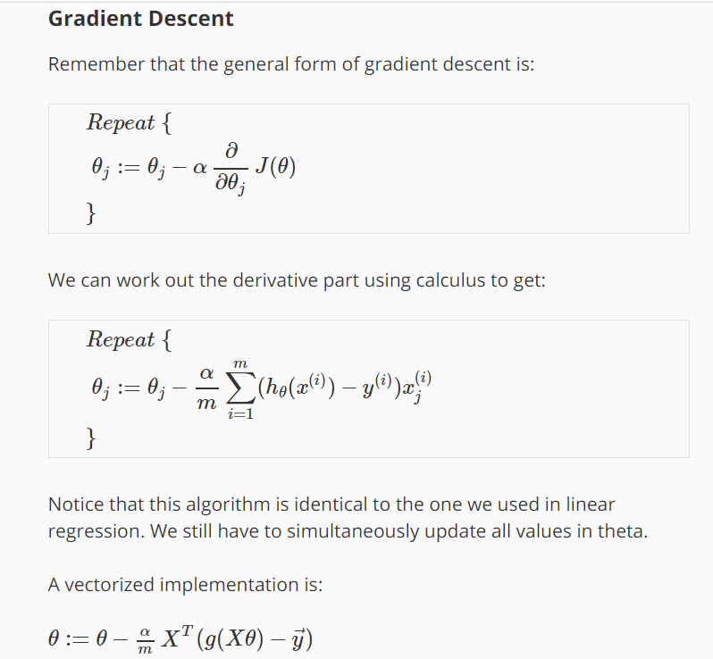

**Advanced Optimization**

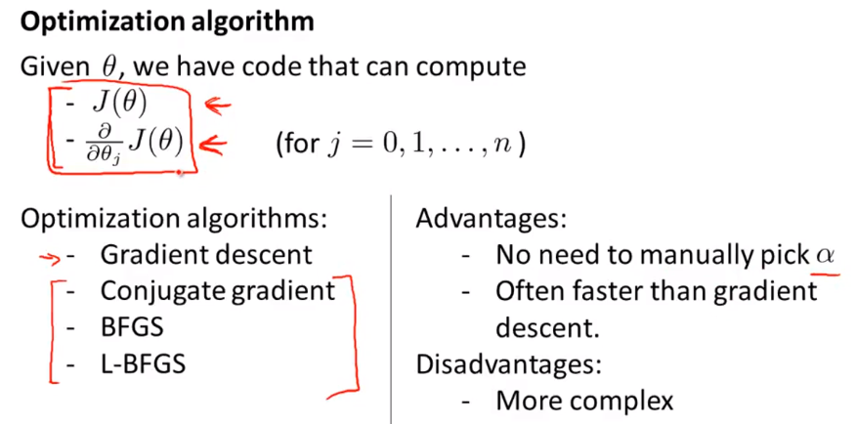

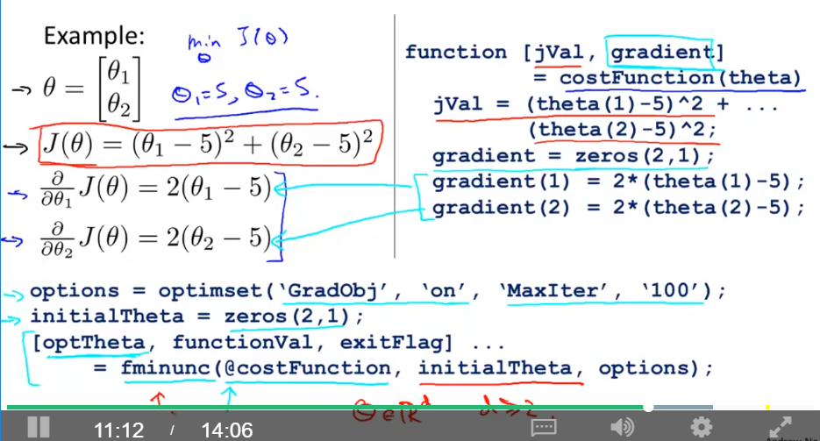

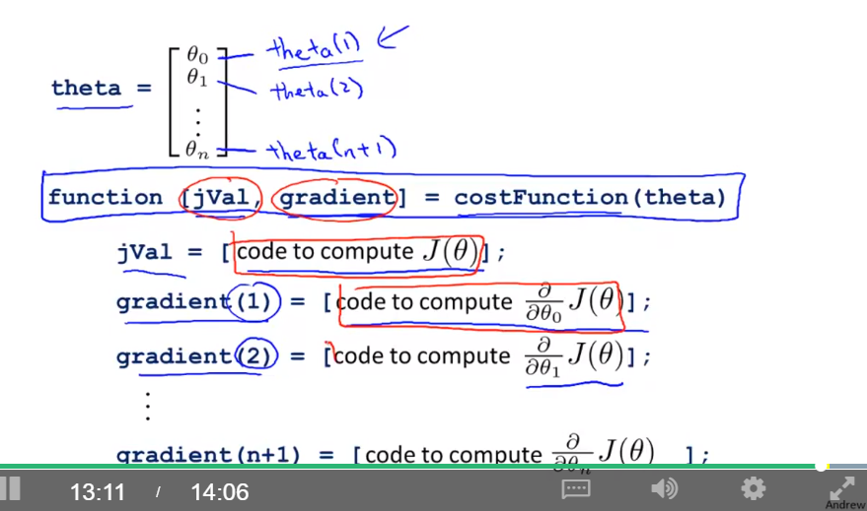

function [jVal, gradient] = costFunction(theta)

jVal = [...code to compute J(theta)...];

gradient = [...code to compute derivative of J(theta)...];

end

options = optimset('GradObj', 'on', 'MaxIter', 100);

initialTheta = zeros(2,1);

[optTheta, functionVal, exitFlag] = fminunc(@costFunction, initialTheta, options);

**Multiclass classification: One-vs-all (One-vs-rest)**

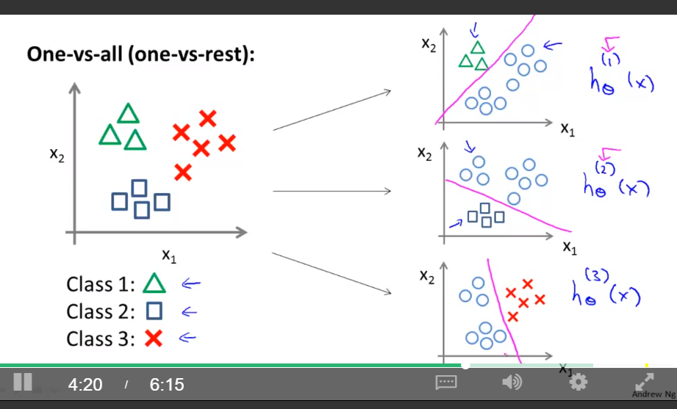

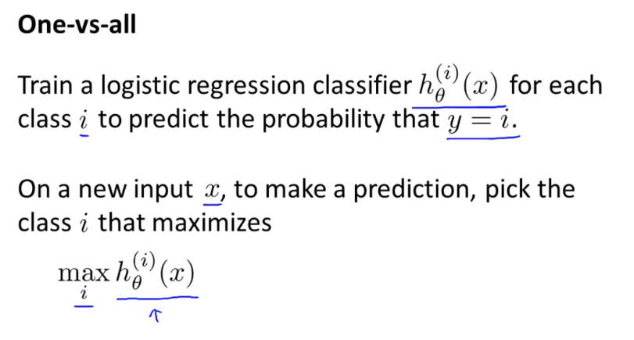

**Overfitting**

Overfitting = High variance

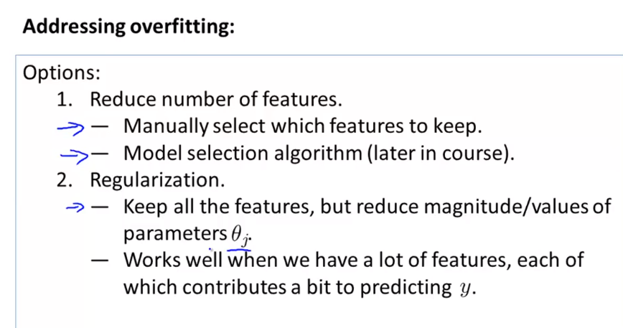

**Regularization – Cost Function**

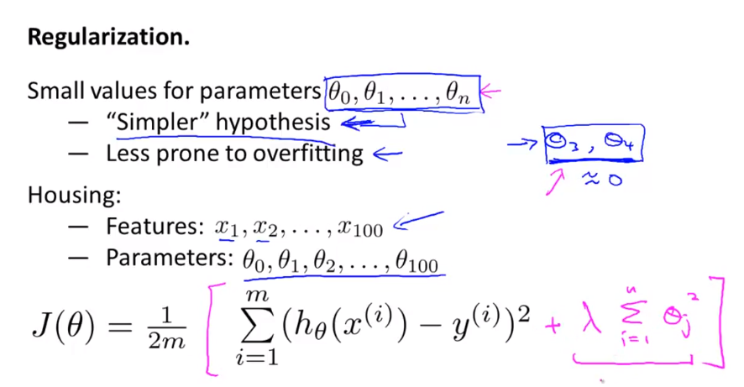

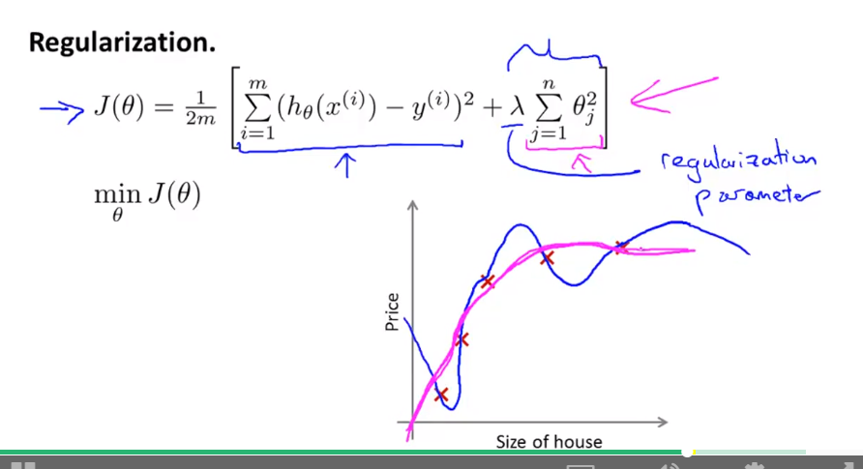

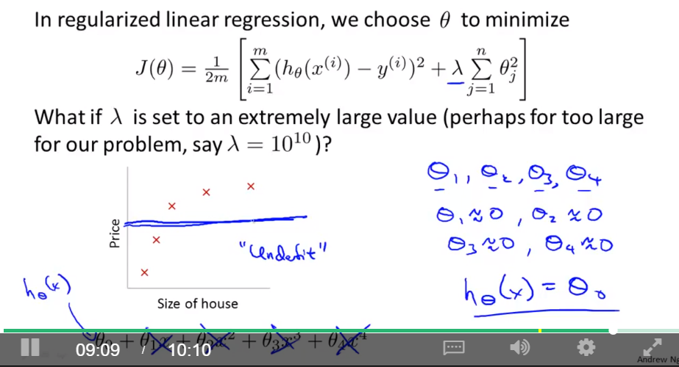

**Regularized linear regression**

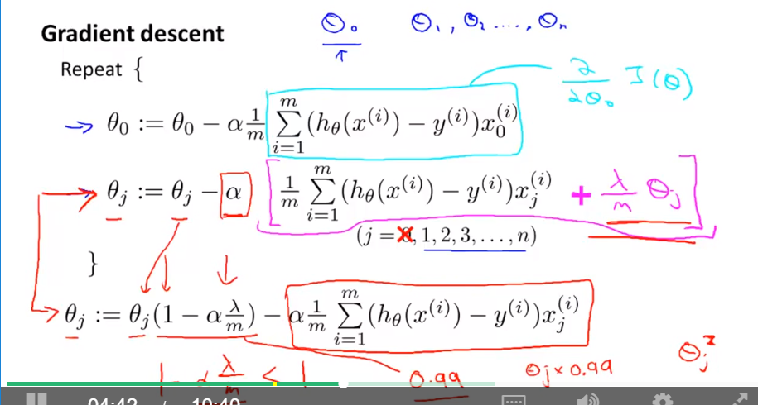

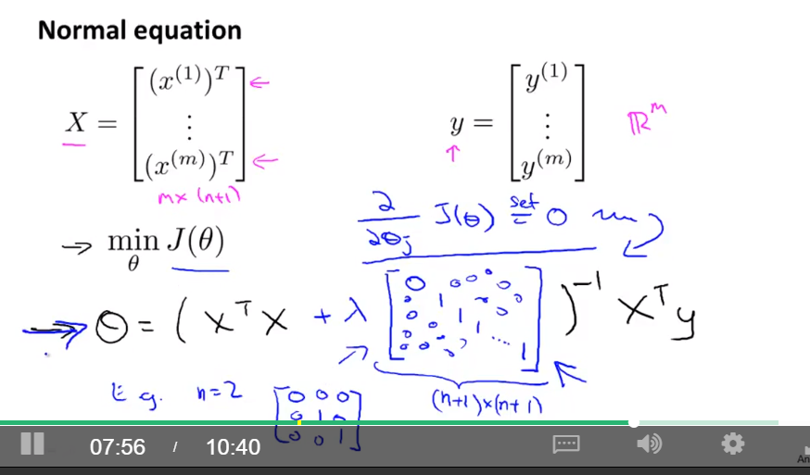

**Regularized Logistic Regression**

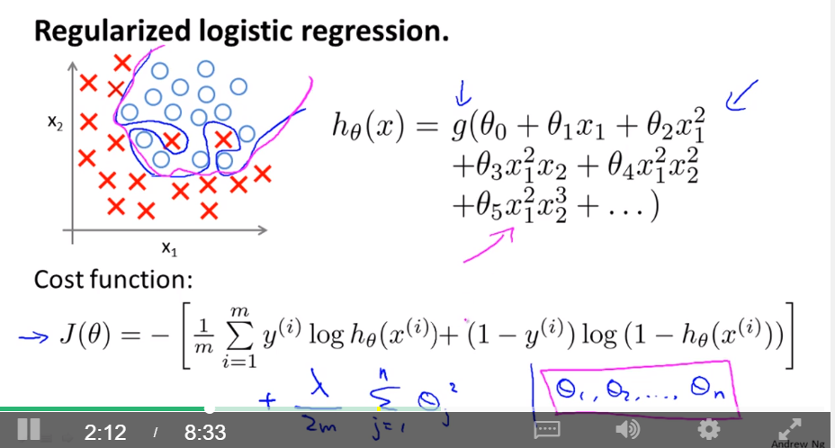

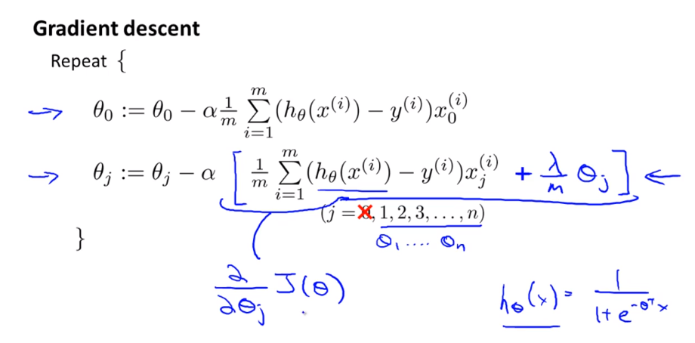

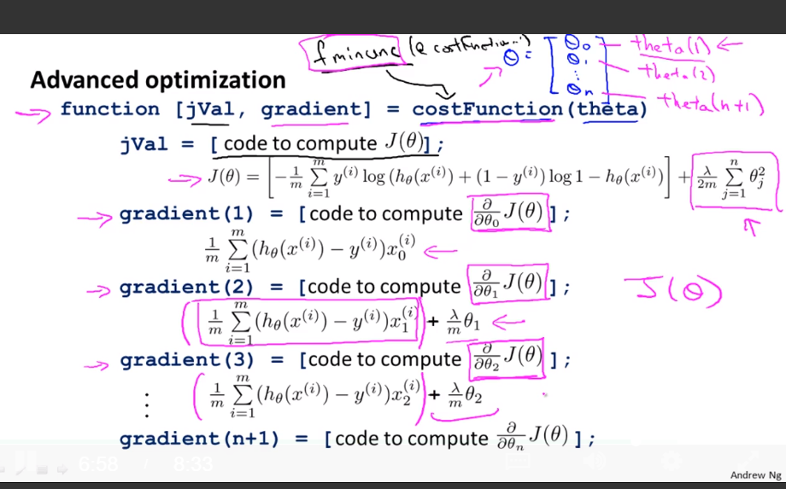

**Week 4**

**Lecture 1-1 – Non-linear Hypotheses**

**Lecture 1-2 – Neurons and the Brian**

**Lecture 2 Neural Networks**

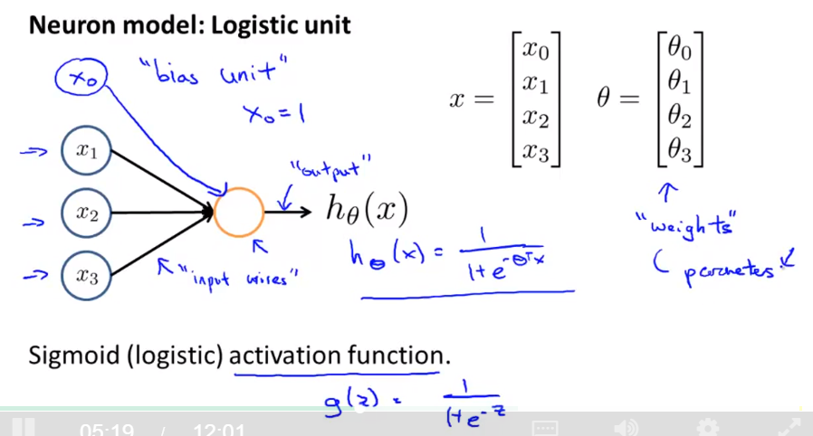

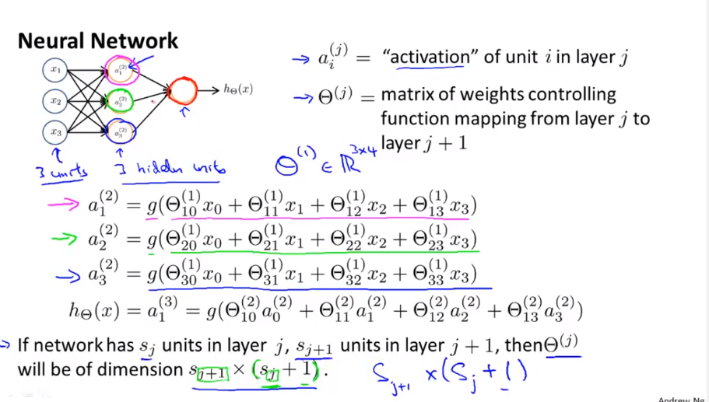

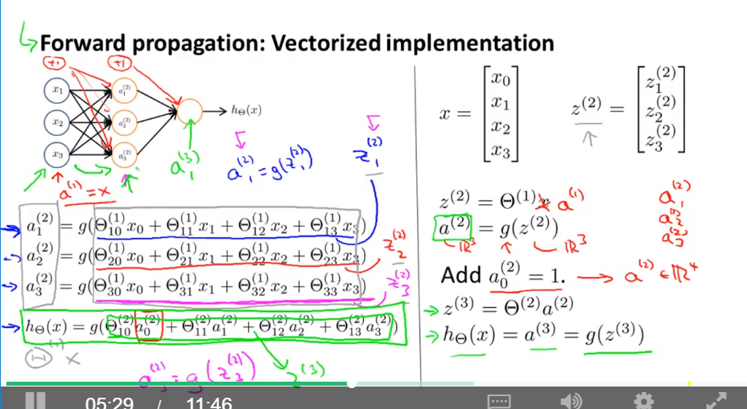

**Neural Networks – Examples and Intuitions I**

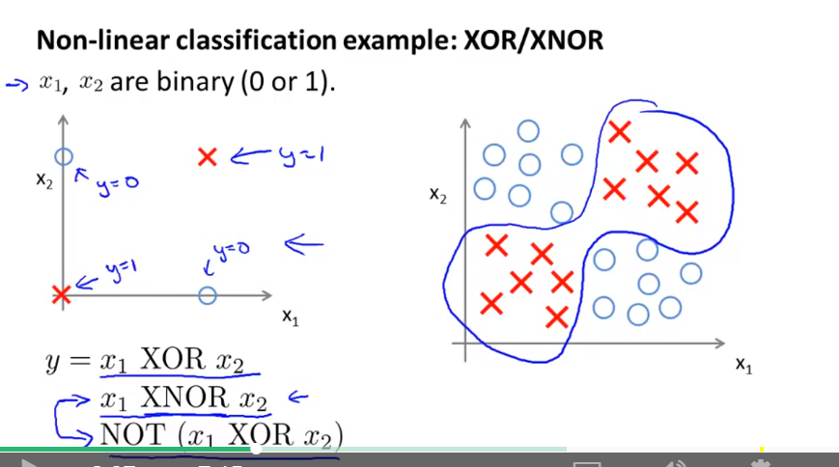

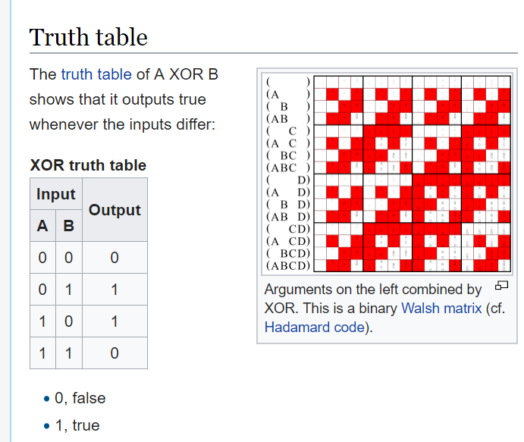

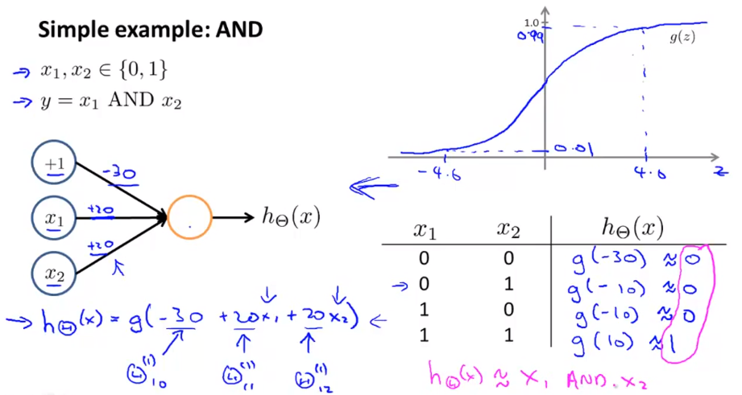

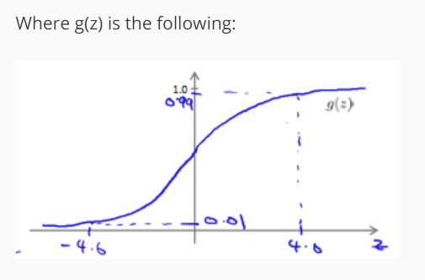

**Neural Networks – Examples and Intuitions II**

Negation – Not x1

**Multiclass classification**